**DAILY ONLINE ACTIVITIES SUMMARY**

|  |  |  |  |  |  |  |  |  |
| --- | --- | --- | --- | --- | --- | --- | --- | --- |
| **Date:** | **03-6-2020** | | | | | **Name:** | **Likhitha.M** | |
| **Sem & Sec** | **6th sem ‘A’** | | | | | **USN:** | **4al17cs046** | |
| **Online Test Summary** | | | | | | | | |
| **Subject** | | **Python Application Program- Assignment 1** | | | | | | |
| **Max. Marks** | | **20** | | **Score** | | | **17** | |
| **Certification Course Summary** | | | | | | | | |
| **Course** | **Cloud Foundations** | | | | | | | |
| **Certificate Provider** | | | **Great learning** | | **Duration** | | | **3 days** |
| **Coding Challenges** | | | | | | | | |
| **Problem Statement:**  1.Take a list of length 3 containing integers, find out which is larger, first or last one and set all the elements in the list to be that value. Print the updated list.  2. Write a python program to generate prime number in an  Interval  Input Format You will be taking two numbers as an input from stdin one on each line respectively.  Constraints 1 <= A, B <= 10^4  Output Format You need to print the prime numbers one on each line.  3.Java Program to Implement Circular Doubly Linked List | | | | | | | | |
| **Status: completed** | | | | | | | | |
| **Uploaded the report in Github** | | | | | **yes** | | | |
| **If yes Repository name** | | | | | **https://github.com/likhithaMantaral/Daily-status** | | | |
| **Uploaded the report in slack** | | | | | **yes** | | | |

Online Test Summary:

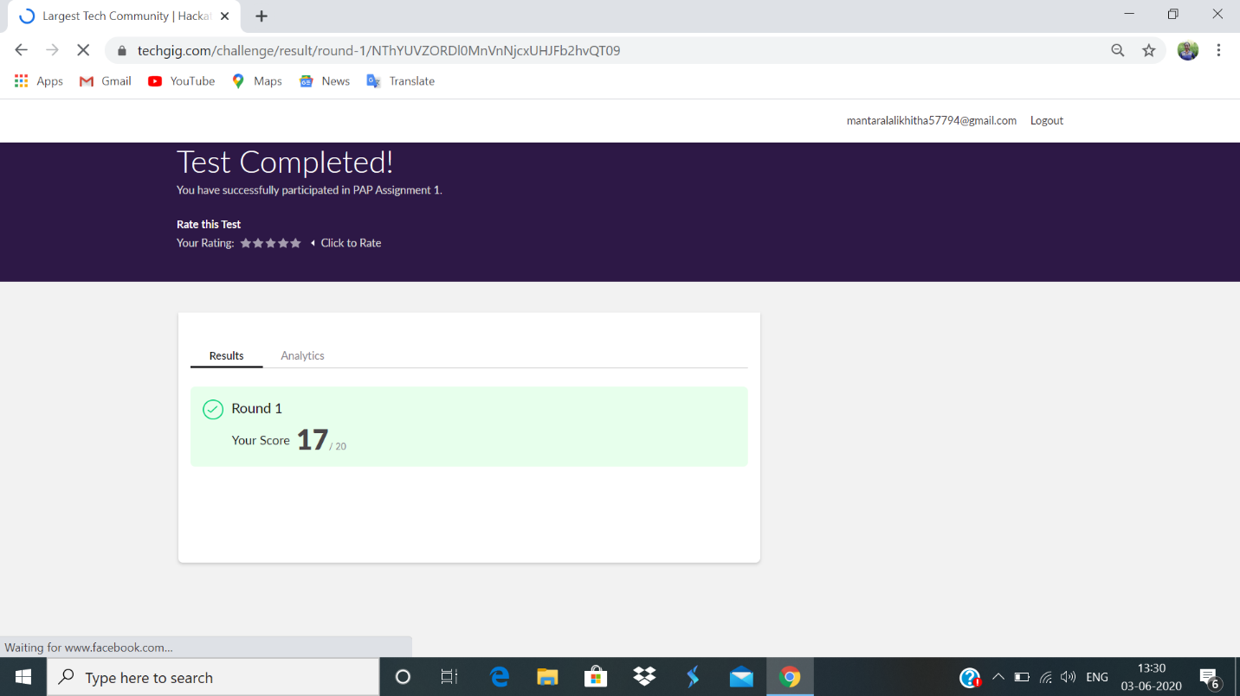

Certification Course Details:

**Apps for Cloud and security model**

Designing application for cloud

1.Evaluate enterprise architecture impact.

2.Choice of the right service provider.

3.Defining the business process and integration touch points.

4.Think stateless, adaptors, foundation.

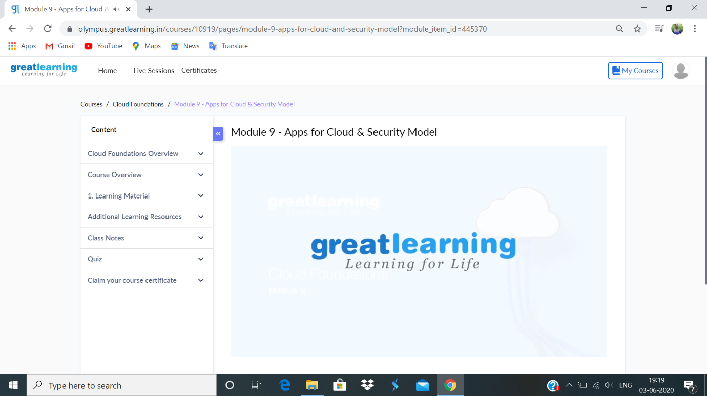

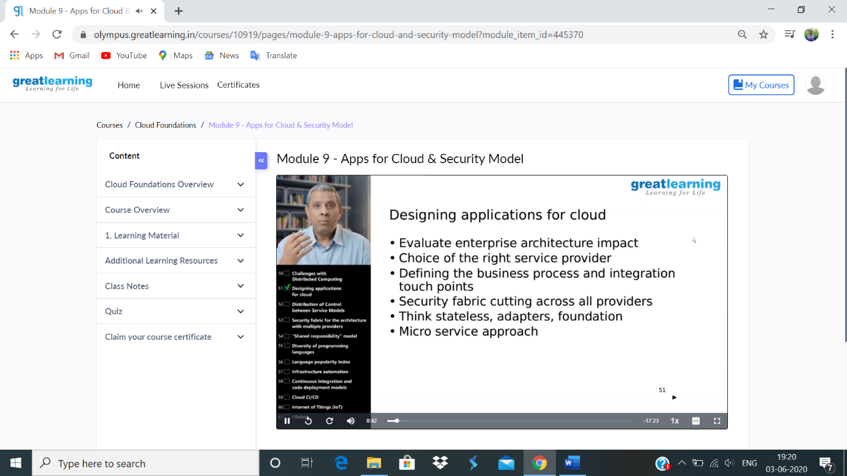

**Coding challenge:**

**1.**

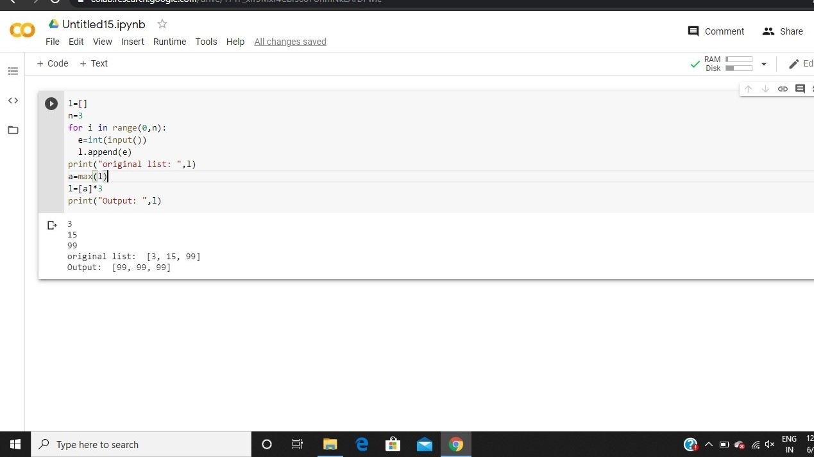

**2.**

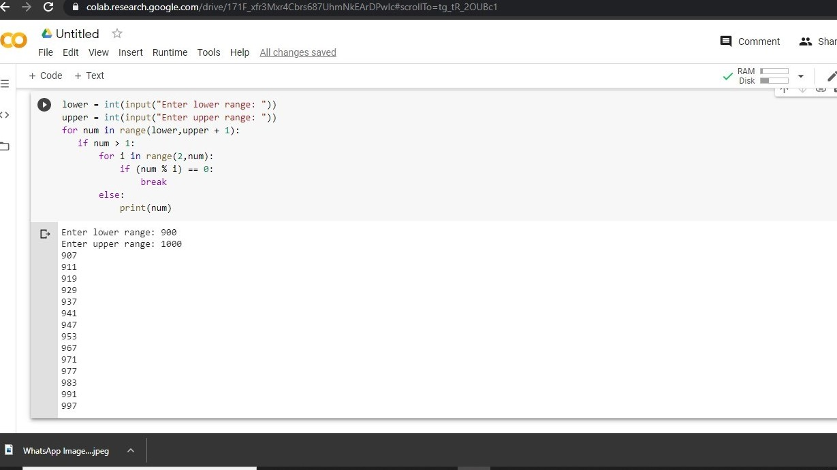

3.

